Optical Sensor Research

Optical sensors are used to convert light rays into an electronic signal, measuring the amount of light energy received by the sensor and converting this into “a form that is readable by an integrated measuring device” (ElProCus, 2020). There are many different ways in which they can achieve this and many different applications for this type of sensor.

What Types of Optical Sensors are There?

The most common kinds of optical sensor, used in real world applications, are:

* Photoconductive devices, converting a change in light into a change in resistance (ElProCus, 2020).
* Photovoltaic cell (solar cell), converting a change in light into an output voltage (ElProCus, 2020).
* Photodiodes, converting a measure of light into an output current (ElProCus, 2020).

The different types of optical sensor are:

* Through-beam sensors

This system uses a transmitter (projects a beam of light) and receiver (senses the beam of light) placed opposite from each other. If an object breaks the beam then the receiver reads this as a switch signal (ElProCus, 2020). An advantage of this type of sensor is that “large operating distances can be achieved” (ElProCus, 2020), and an interruption in the beam will be sensed regardless of the size, shape, reflectivity or colour (ElProCus, 2020).

* Retro-reflective sensors

This type of sensor uses a transmitter and receiver built within the same casing, with a reflector placed opposite the casing. The transmitter emits a beam of light which is reflected back to the receiver. As with the through-beam sensor, an interruption in the beam is read as a switch signal by the receiver (ElProCus, 2020). This sensor is advantageous due to its ability to “enable large operating distances” (ElProCus, 2020) and object detection, with the size, shape, colour and reflectivity of the object having no effect on its detection (ElProCus, 2020).

* Diffuse reflection sensors

This system uses a transmitter and receiver built into the same casing, with the transmitter emitting a beam of light and an object (to be detected) acting as the reflective surface for the light to be returned to the receiver (ElProCus, 2020). In this system, the light intensity detected by the receiver causes a switch to occur. This system can incur error during the switching process, due to “the rear part reflecting better than the front part” (ElProCus, 2020), no matter what sensitivity the receiver is set to.

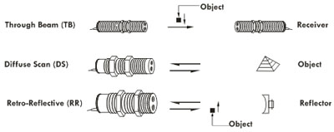

**Figure 1:** Image showing the different types of optical sensors (BeeInstruments, 2020).

What are Typical Applications of Optical Sensors?

There are a wide range of applications for optical sensors. Some of these include:

* Ambient light sensors for mobile devices

These types of sensors are usually used in mobile devices such as phones and tablets. They are used to allow for the adjustment of the device’s display, correcting for the background lighting experienced by the user. This optimises the screen brightness for the user’s vision and also allows for as little battery life consumption as possible (ElProCus, 2020).

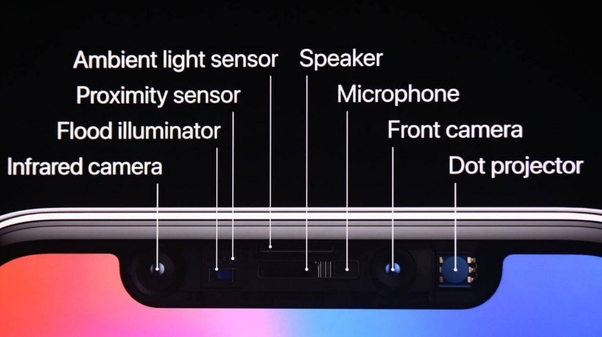

**Figure 2:** An image showing the many different sensors used in the iPhone X, one of which being an ambient light sensor (Scott, M. 2017).

* Heart rate monitors in the biomedical sector

Optical heart rate monitors transmit LED light through a subject’s skin, reading the amount of light reflected back to determine their heart rate. “Fluctuations in heart rate can be translated into heart rate” (ElProCus, 2020) because blood absorbs more light than the skin. When the heart beats and the heart is filled with more blood, less light is reflected than when the heart has less blood inside. “This process is called photoplethysmography” (ElProCus, 2020).

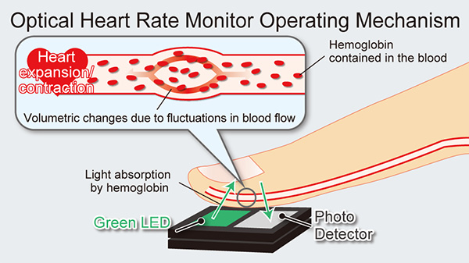

**Figure 3:** an image detailing how an optical heart rate monitor functions (Rohm, 2020).

* Liquid level sensors in multiple sectors

This system is used to measure the amount of liquid within a given container. It works by using a diffuse reflection type sensor, sending out a beam of light from a transmitter and reading the amount of light that is reflected using a receiver. If there is no liquid at the level of the sensor then the full amount of light will be reflected, but if the liquid is at the same height as the sensor then it will cause the emitted light to “disperse” (ElProCus, 2020) and less light will be reflected back to the receiver.

[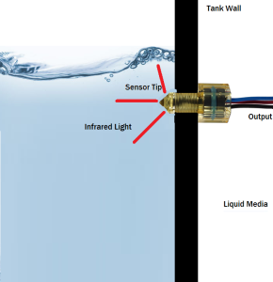](https://www.fluidswitch.com/wp-content/uploads/sites/2/2015/10/Optical-Sensor-1.png)

**Figure 4:** An image showing the components of a liquid level sensor (SMDFluidControls, 2020).

How Can Control be Achieved by a Microprocessor, Sensors and Motors?

A microprocessor is required to control optical sensors. A microprocessor is “a component that performs the tasks involved in computer processing, executing and managing the logical instructions passed to it” (Techopedia, 2019). Microprocessors are built on silicon chips, with silicon being used because of its “abundance and semi-conductive properties” (Templeton, G. 2015). These chips are programmed with code written in languages such as C++, Python, Java, etc. (Weinberger, M. 2015). This type of language is called a “high level language” (Dev, R. 2012) because it consists of mostly English words, some of which are misspelt, but allows humans to understand the code easier. Once the code is written in a high-level language, it will be translated into a low-level machine language, written in binary. This allows the machine that the code has been written for to understand the instructions that it has been given (Dev, R. 2012). There are also mid-level languages such as C, which “contains aspects from both high level and low-level languages” (Dev, R. 2012), being a mixture of words and binary.

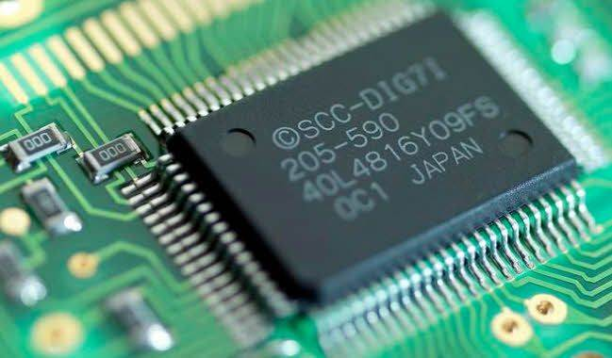

**Figure 5:** An image showing a microprocessor installed on a circuit board (InstantAssignmentHelp, 2020).

“A sensor is a type of transducer, used to generate an input signal to a measurement, instrumentation or control system” (Admin, 2014). Sensors are split into two types, active and passive. Active sensors are able to “generate a signal without the need of a power supply” (Admin, 2014) whereas passive sensors “require an external power supply to generate a signal” (Admin, 2014). Photovoltaic sensors are used within solar panels and are an example of an active sensor. They receive light energy and convert this into electrical energy. In a house, this energy would be used to power home appliances and any excess energy would be able to be sold back to the national grid.

In a solar tracker, this energy would not only be used to power external devices (e.g. a phone charger), but would also need to use some of the electrical energy to power the motors used to move the tracker into an optimal position to receive as much light energy as possible. “A motor is a type of actuator, used to convert an input signal into an action, in this case mechanical” (Admin, 2014).

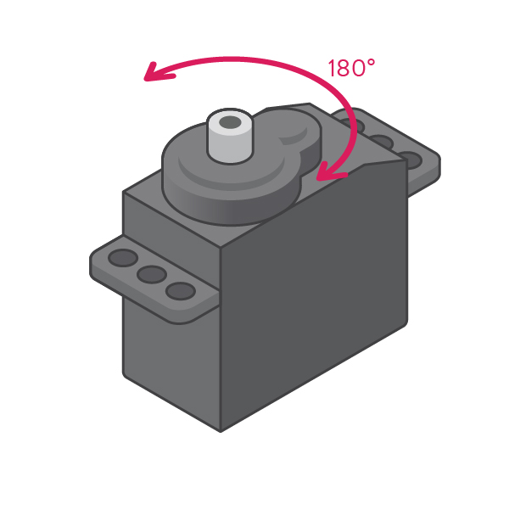

**Figure 6:** An image showing a servomotor, a motor which only has a rotation of 180 degrees, 90 degrees both clockwise and anti-clockwise (Strawbees, 2020).

* Discuss closed-loop control

A control system is “when a number of elements are combined together to form a system to produce desired output” (Electrical4U, 2019). Open loop systems “consider the input and repeat the same task given” (ComputerScienceWiki, 2020), whereas closed loop systems “also consider other factors, including the output itself” (ComputerScienceWiki, 2020). Closed-loop control systems have many applications in industries including agriculture, chemical plants, quality control, nuclear power plants, water treatment plants and environmental control (WhatIs, 2020). A closed loop system will modify itself depending on the input received from sensors and provide different outputs depending on the situation (ComputerScienceWiki, 2020), which means that this type of system is required for optical sensors to function.

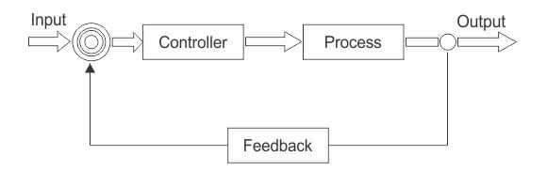

**Figure 7:** A diagram detailing the process involved in a closed loop control system (InstrumentationForum, 2018)

References

Admin. ElectricalBasicProjects (2014) *Electrical Sensors – Basics, definitions, Types.* Available at: http://www.electricalbasicprojects.com/electrical-sensors-basics-definition-types/ (Accessed 24/02/2020)

BeeInstruments (2020) *Optical Sensors.* Available at: http://www.beeinstruments.com/optical_sensors.html (Accessed 24/02/2020)

ComputerScienceWiki (2020) *Microprocessors and Sensor Output in Control Systems.* Available at: https://computersciencewiki.org/index.php/Microprocessors_and_sensor_input_in_control_systems (Accessed 24/02/2020)

Dev, R. Durofy (2012) *High Level Vs Low Level Programming Languages.* Available at: http://durofy.com/high-level-vs-low-level-programming-languages (Accessed 24/02/2020)

Electrical4U (2019) *Control System | Closed-Loop Open-Loop Control System.* Available at: https://www.electrical4u.com/control-system-closed-loop-open-loop-control-system/ (Accessed 19/02/2020)

ElProCus (2020) *Optical Sensor Basics and Applications.* Available at: https://www.elprocus.com/optical-sensors-types-basics-and-applications/ (Accessed 14/02/2020)

InstantAssignmentHelp (2020) *Microprocessor Assignment Help.* Available at: https://www.instantassignmenthelp.com/microprocessor-assignment-help (Accessed 24/02/2020)

InstrumentationForum (2018) *What is Closed Loop Control System?* Available at: https://instrumentationforum.com/t/what-is-closed-loop-control-system/6526 (Accessed 24/02/2020)

Rohm (2020) *New High-Performance Optical Sensor for Heart Rate Monitoring Ideal for Wearables.* Available at: https://www.rohm.com/news-detail?news-title=new-high-performance-optical-sensor-for-heart-rate-monitoring&defaultGroupId=false (Accessed 24/02/2020)

Scott, M. All3DP (2017) *What the iPhone X Could Mean for 3D Scanning.* Available at: https://all3dp.com/iphone-x-mean-3d-scanning/ (Accessed 24/02/2020)

SMDFluidControls (2020) *How do Optical Level Sensors Work?* Available at: https://www.fluidswitch.com/2015/10/16/how-do-optical-level-sensors-work/ (Accessed 24/02/2020)

Strawbees (2020) *Servo Motor.* Available at: https://strawbees.com/product/servo-motor/ (Accessed 24/02/2020)

Techopedia (2019) *Microprocessor.* Available at: https://www.techopedia.com/definition/2874/microprocessor (Accessed 24/02/2020)

Templeton, G. ExtremeTech (2015) *What Is Silicon, And Why Are Computer Chips Made from It?* Available at: https://www.extremetech.com/extreme/208501-what-is-silicon-and-why-are-computer-chips-made-from-it (Accessed 24/02/2020)

WhatIs (2020) *Closed Loop Control System.* Available at: https://whatis.techtarget.com/definition/closed-loop-control-system (Accessed 14/02/2020)